2011

Exhibition-Fair «House of the gardener is family support»
Moscow, State Duma of the Russian Federation

Certificate
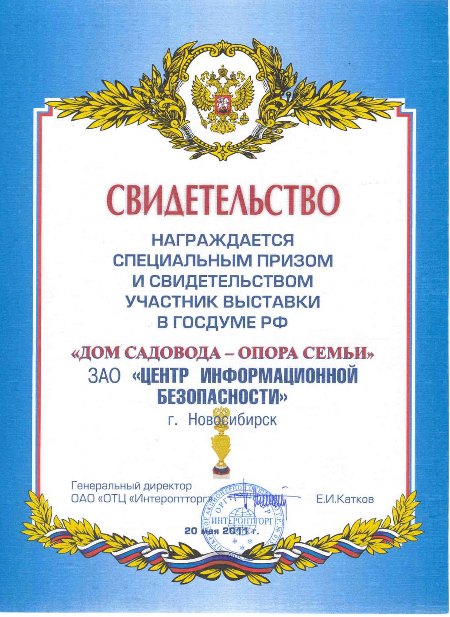

Special Prize
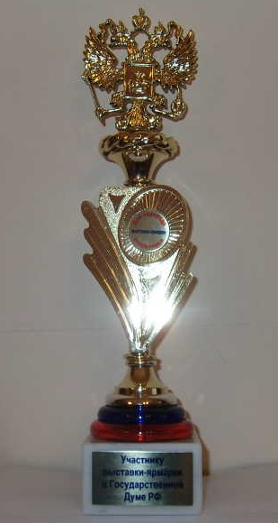

Exhibition-Fair «Update the garden»
Moscow, Russia

The Winner of the Exhibition in the nomination «The best goods of the exhibition»
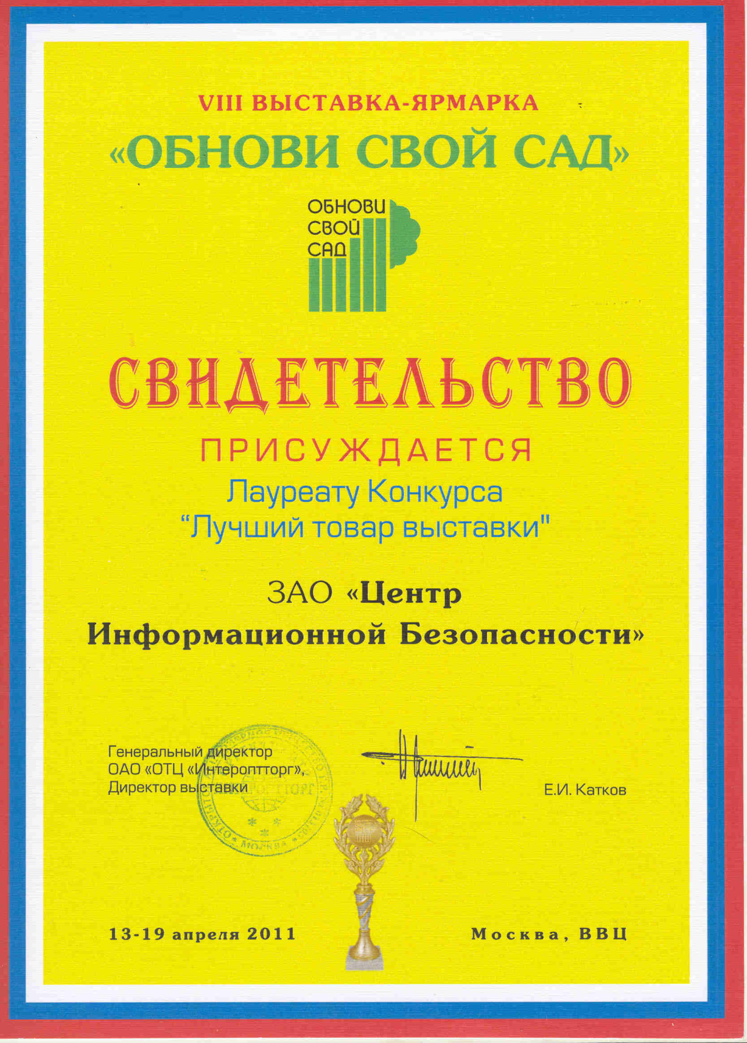

The special prize

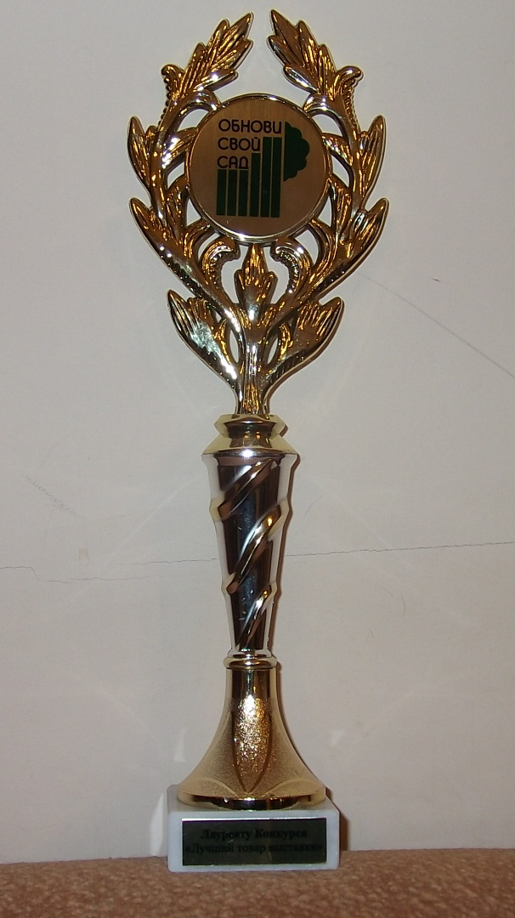

Specialized exhibition all for country-house
All-russian competition «The best country goods - 2011»
Moscow, Russia

The WINNER of competition
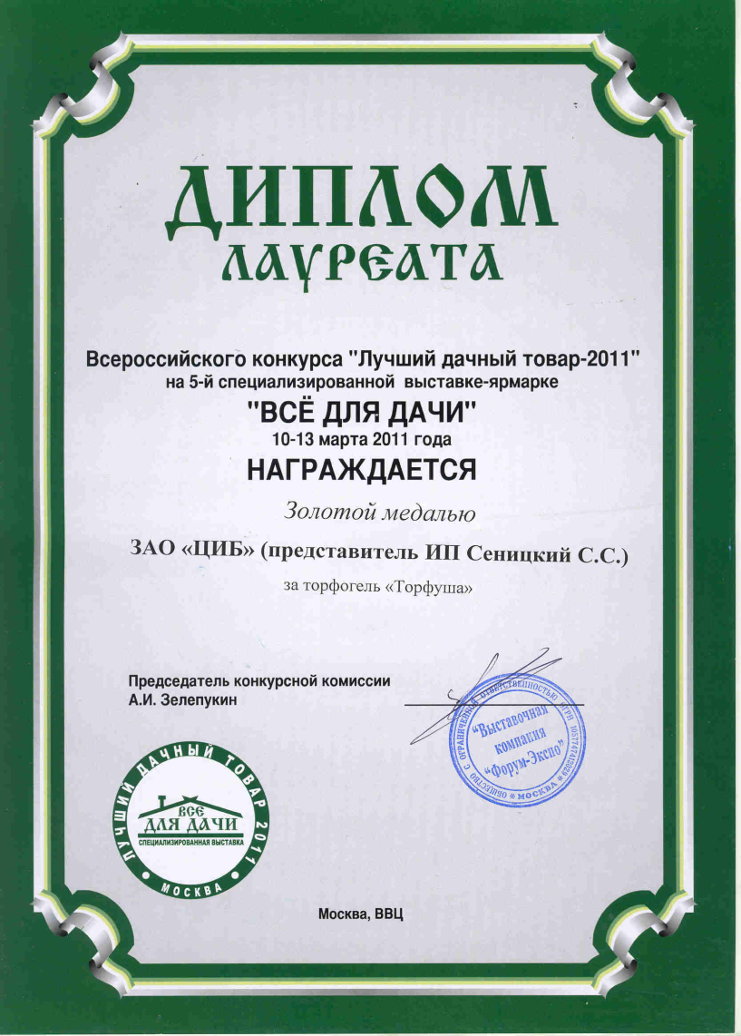

Gold medal
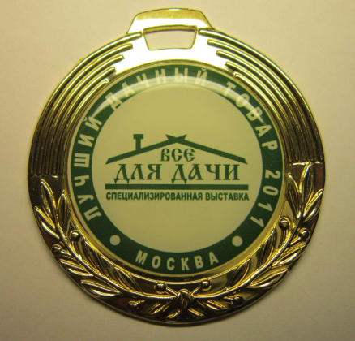

1-st Specialized Exhibition-Fair "Our country-house” Russia, Moscow

DIPLOMA for introduction of high-quality production
